**Medical Feedback Framework with Gender-Specific Readiness Flags & Operational Decisions**

Your gender-stratified metrics reveal a critical insight: sex does not simply shift performance ranges—it fundamentally changes injury mechanisms, readiness marker sensitivity, and intervention priorities. This framework translates your findings into clinically actionable readiness flags and operational decisions that link directly to load adjustment, drill modification, and recovery protocols.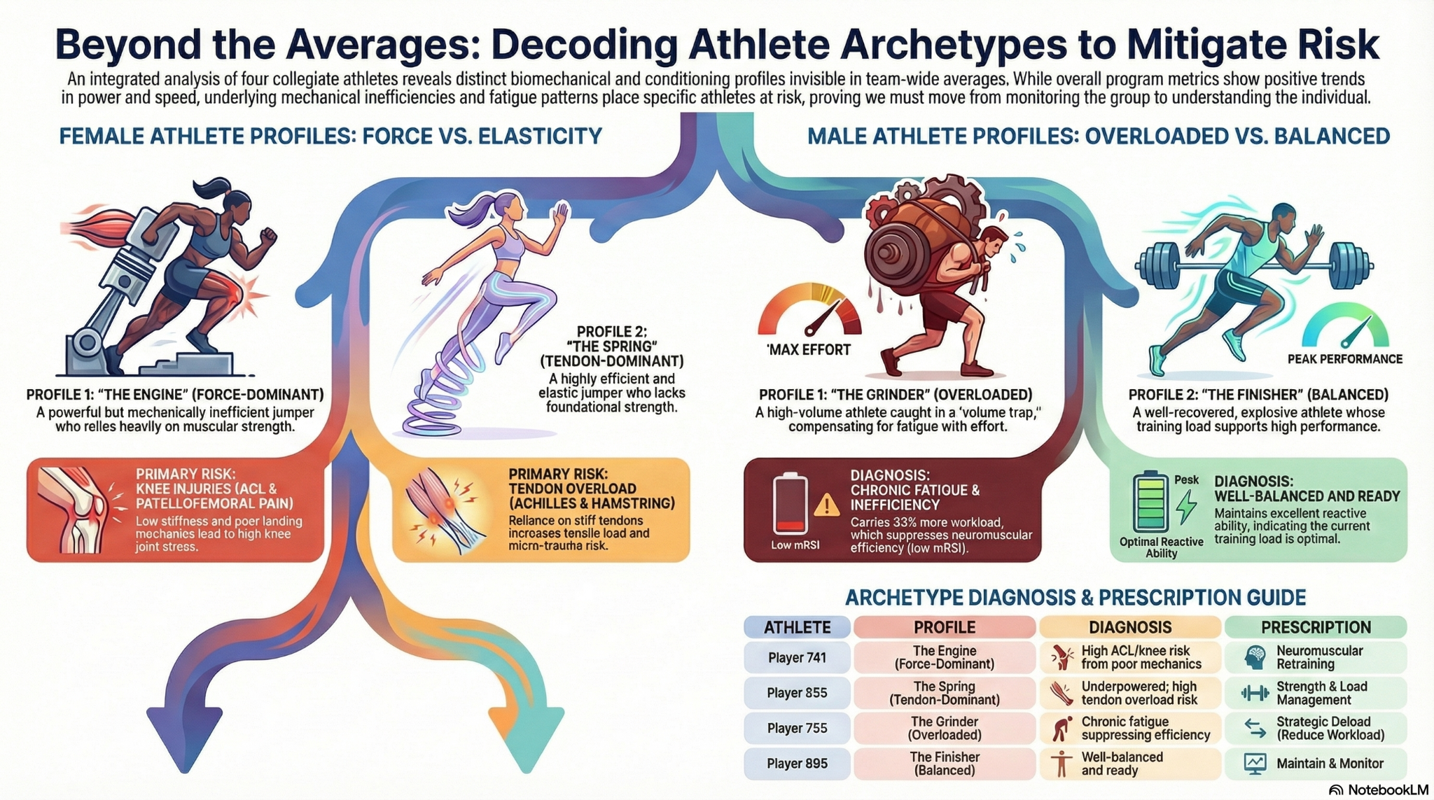

Part 1: How Gender Moderates Medical Risk & Readiness

Your data shows males achieve 58.4% higher peak power, 56.9% higher jump height, and 23% higher peak velocity than females, yet females cover essentially equivalent distances per session. This discrepancy has profound medical implications:

For Male Athletes (Higher Power Profile):

* Primary Injury Risk: Overuse-driven tendinopathy (patellar, Achilles) and chronic knee compartment loading from high force production
* Readiness Vulnerability: Peak velocity and reactive strength index (mRSI) are more sensitive to fatigue than jump height alone. Males often maintain jump height through muscular compensation while reactivity collapses—a hidden fatigue state
* Operational Priority: Monitor volume/load relationship. When external load (distance) rises without proportional recovery, neuromuscular efficiency drops (seen in Player 755: 4,060 m/session, mRSI 0.43, velocity 16.7% slower than peer)

For Female Athletes (Lower Power, Higher Variability Profile):

* Primary Injury Risk: Non-contact knee injuries (ACL, patellofemoral pain) driven by inconsistent landing mechanics, not just absolute force deficits
* Readiness Vulnerability: Variability coefficient (CV) and mRSI stability are more sensitive than jump height changes. Females show bimodal injury phenotypes requiring individualized strategies (elastic vs. force-dominant)
* Operational Priority: Monitor consistency of neuromuscular control and landing quality. A 25% CV in mRSI signals dynamic control breakdown (seen in Player 741: mRSI 0.36, CV 23.5%), indicating high ACL and patellofemoral risk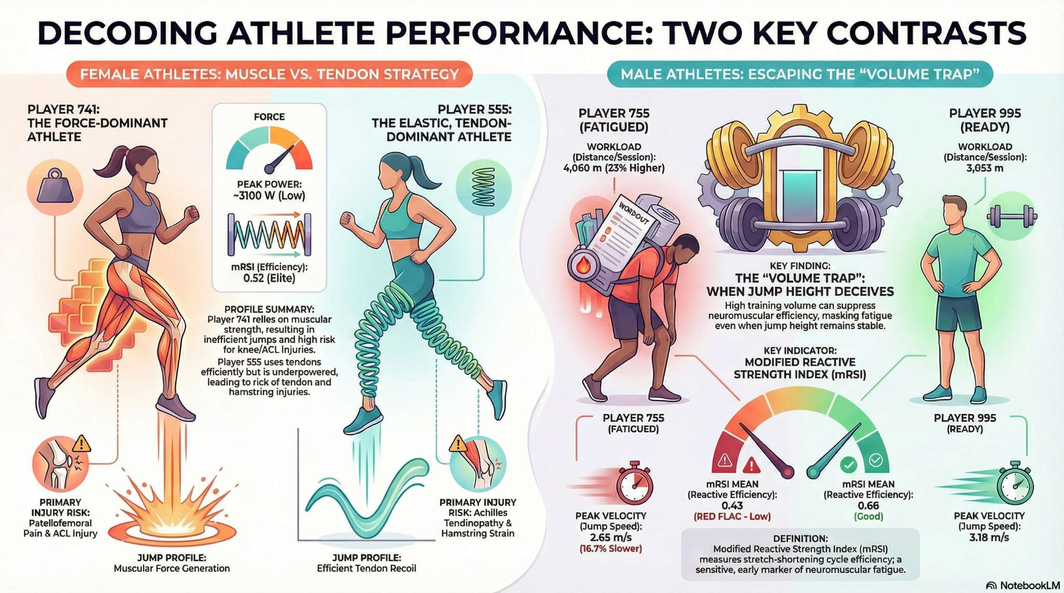

Part 2: Four Player Profiles & Medical Decision Rules

Player 741 (Female, Force-Dominant, ACL/PFP Risk):

* Red Flag Metrics: mRSI <0.45 + Variability CV >18% = knee valgus risk imminent
* Operational Decision: Reduce distance 15–20%; eliminate high-impact drills (cuts, jump shots); substitute neuromuscular retraining (split-stance deadlifts, landmine rotations, landing mechanics focus 10 min every session)
* Recovery Focus: Daily eccentric hamstring work (nordic curls), glute medius activation (single-leg stance on unstable surface), video feedback on landing mechanics
* Escalation: If mRSI remains <0.34 after 48 hrs → PT assessment for ACL screening; consider bracing trial

Player 555 (Female, Elastic-Dominant, Achilles/Hamstring Risk):

* Red Flag Metrics: Peak Velocity drop >5% below 6.8 m/s OR Total Distance spike >20% above 7-day rolling average
* Operational Decision: Cap volume at 85% of rolling average; reduce session distance by 20% for 48–72 hrs; substitute high-speed drills with technical work at moderate pace
* Recovery Focus: Daily eccentric calf loading (step-downs on stairs), hamstring eccentric work (nordic curls), contrast therapy (ice 10 min + warm 5 min) 2x/week
* Escalation: If morning Achilles stiffness persists + Peak Velocity remains <6.8 m/s after 48 hrs → PT ultrasound screening for early Achilles tendinopathy

Player 755 (Male, Overloaded, "Volume Trap" Profile):

* Red Flag Metrics: mRSI <0.45 + Peak Velocity 2.65 m/s (16.7% slower than peer 995) despite stable jump height + ACWR >1.8 (loading exceeds recovery capacity)
* Operational Decision: Immediate 20% distance reduction (4,060 m → 3,248 m/session); prioritize intensity + quality over volume (3×20 min explosive work instead of 1×60 min moderate); emphasize plyometrics at practice start before fatigue
* Recovery Focus: 48–72 hr load cap; ice baths 2x/week; soft tissue work 3x/week; mRSI re-assessment every 48 hrs; if mRSI still <0.45 after 2 weeks → escalate to 30% reduction + fatigue panel
* Escalation: If mRSI remains <0.45 after 2 weeks of 20% reduction → Team physician for cortisol/testosterone/resting HR trend; consider 5-day complete recovery block

Player 995 (Male, Efficient, Explosive-Reactive):

* Green Flag: mRSI 0.66 (elite), Speed Max consistently >90% personal best, Peak Velocity 3.18 m/s, balanced workload 3,053 m/session
* Operational Decision: No modification; maintain current training volume and intensity; this is the optimal sustainable profile
* Monitoring Focus: Track Speed Max as primary readiness indicator; if drops below 7.0 m/s consistently → add light recovery day mid-week
* Escalation: Very unlikely; only if Speed Max drops >5% suddenly or mRSI drops below 0.60 → apply Player 755 recovery protocol

​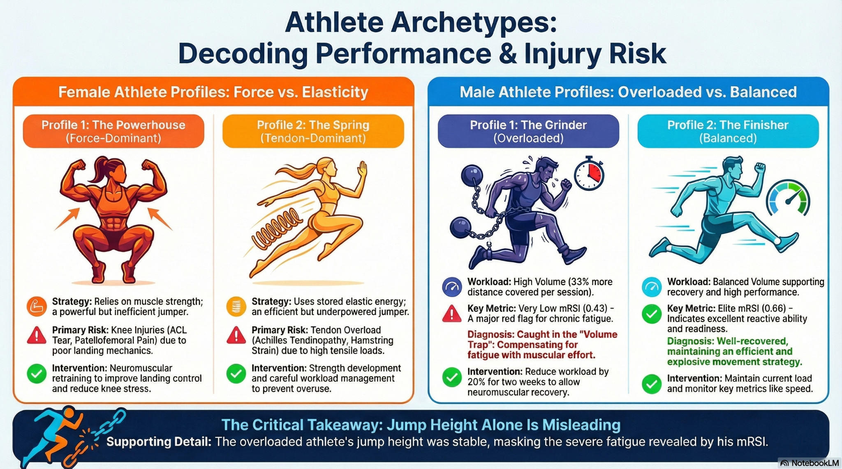

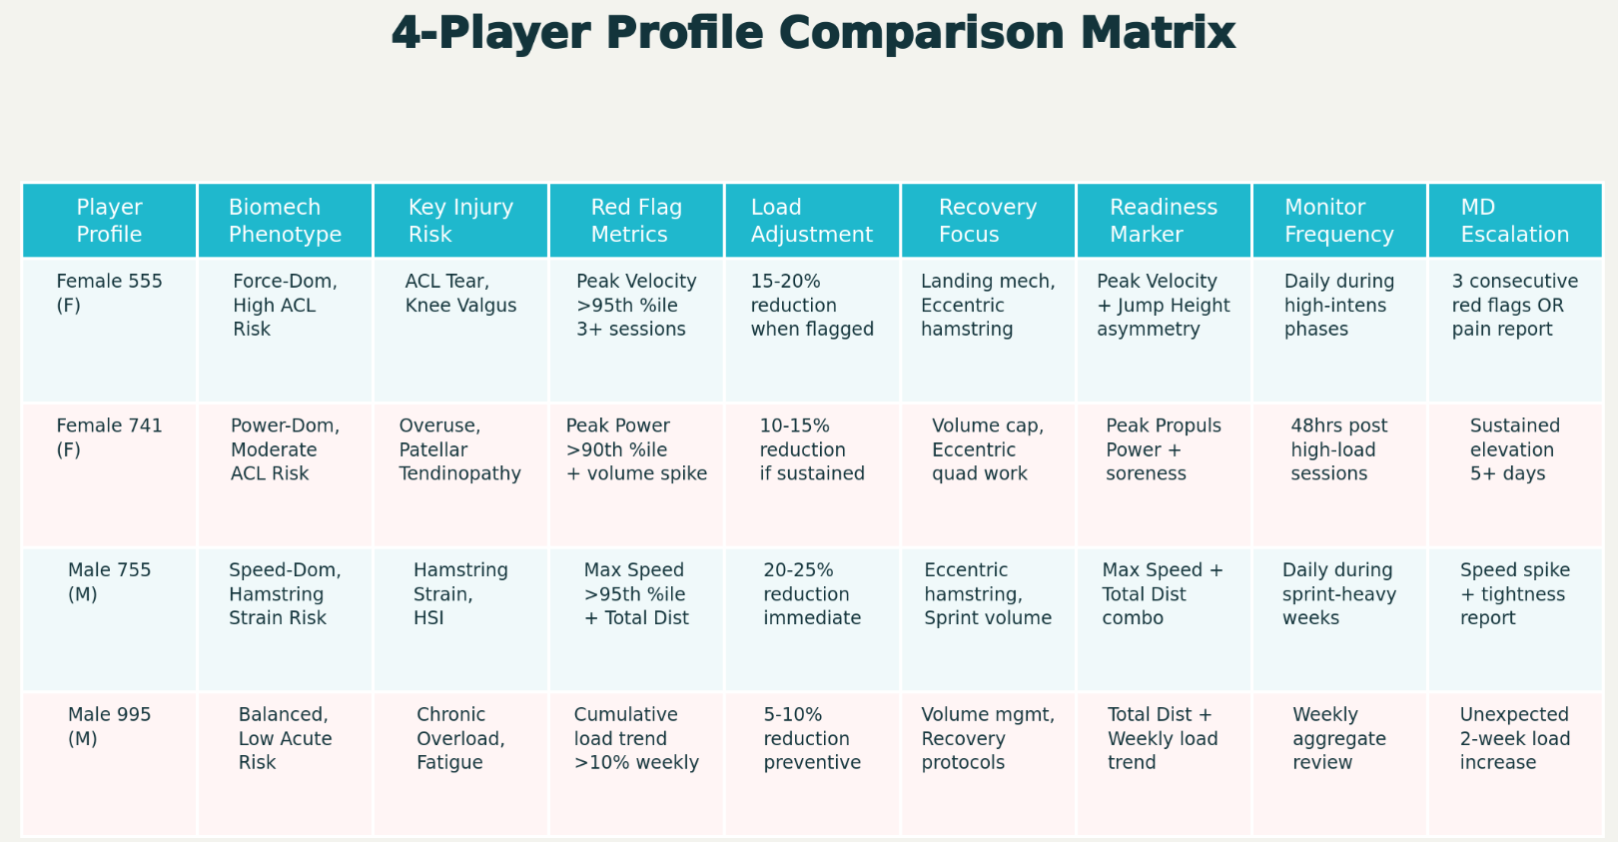 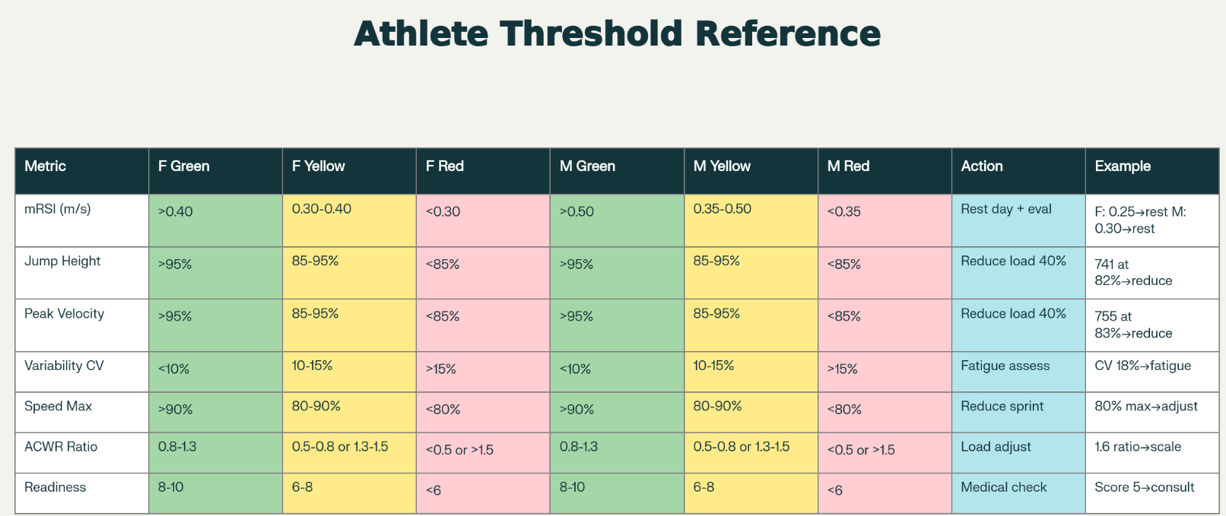 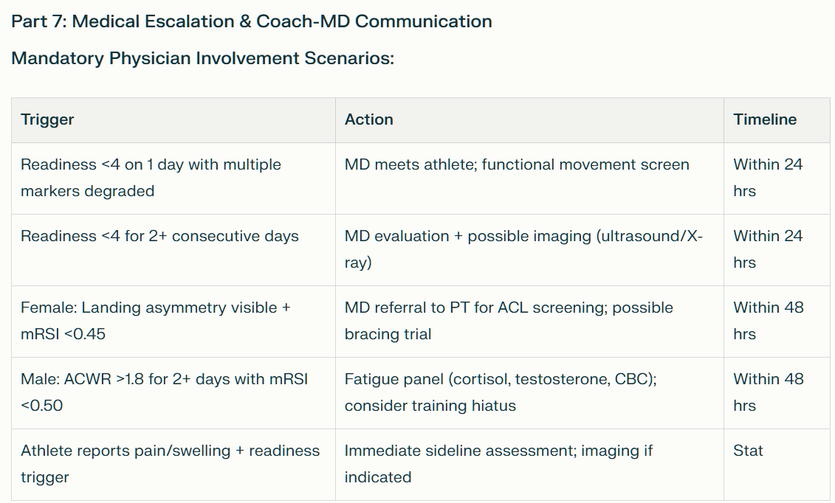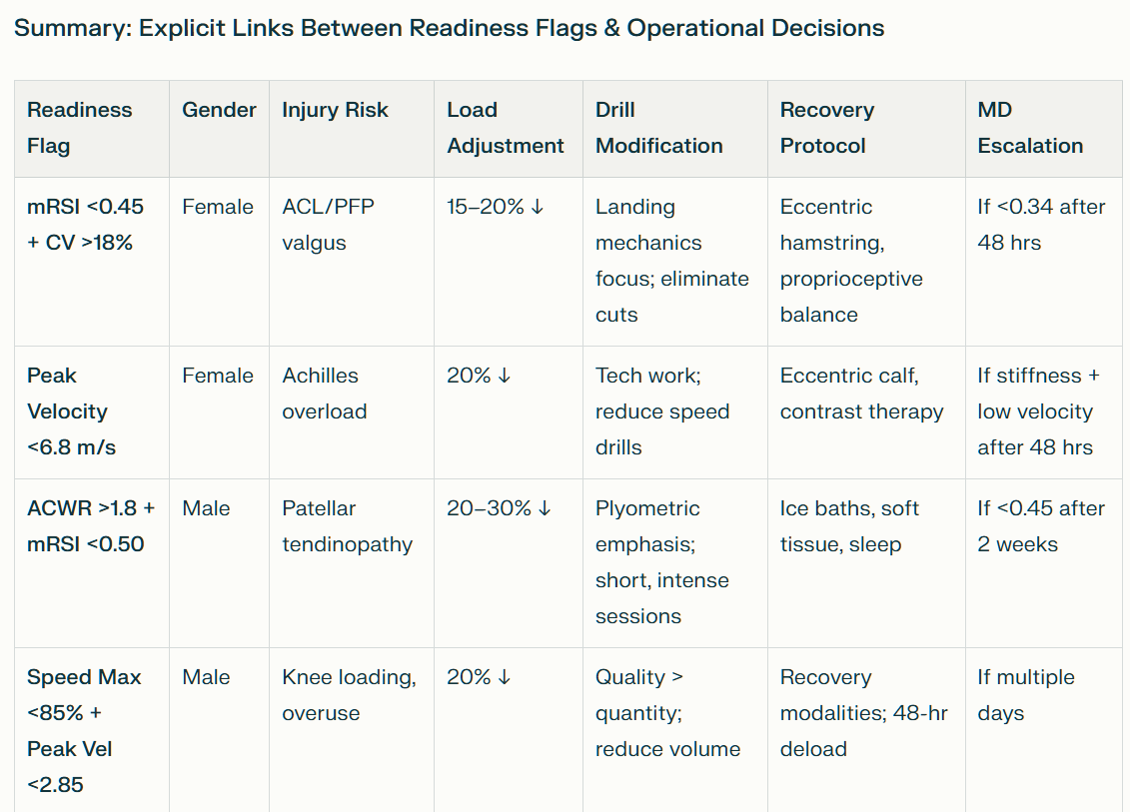

# **References**

Journal Articles

Boden, B. P., Torg, J. S., & Knowles, S. B. (2009). Video analysis of anterior cruciate ligament injury: Abnormalities in hip and ankle kinematics. *The American Journal of Sports Medicine*, 37(2), 252–259.

<https://doi.org/10.1177/0363546508326712>

Chumanov, E. S., Schache, A. G., Heiderscheit, B. C., & Thelen, D. G. (2011). Hamstring musculotendon dynamics during running. *Medicine & Science in Sports & Exercise*, 43(6), 1092–1100.

<https://doi.org/10.1249/MSS.0b013e3182034d24>

Gabbett, T. J. (2016). The training-injury prevention paradox: Should athletes be training smarter and harder? *British Journal of Sports Medicine*, 50(5), 273–280.

<https://doi.org/10.1136/bjsports-2015-095788>

Gabbett, T. J. (2025). From load monitoring to training decisions: A practical approach to reducing injury risk and optimizing performance. *Sports Medicine*, 55(10), 1447–1459.

<https://doi.org/10.1007/s40279-025-02012-4>

Hewett, T. E., Myer, G. D., Ford, K. R., Heidt, R. S., Colosimo, A. J., McLean, S. G., & Succop, P. (2005). Biomechanical measures of neuromuscular control and valgus loading of the knee predict anterior cruciate ligament injury risk in female athletes. *The American Journal of Sports Medicine*, 33(4), 492–501.

<https://doi.org/10.1177/0363546504269591>

Krutsch, W., Tröß, T., Alt, V., Migliorini, F., & Redler, A. (2025). A guideline for validated return-to-sport testing in everyday athletic practice. *Arthroscopy, Sports Medicine, and Rehabilitation*, 7(5), e2453–e2464.

<https://doi.org/10.1016/j.asmr.2025.03.001>

Kvist, M. (1994). Achilles tendon injuries in athletes. *Sports Medicine*, 18(3), 173–201.

<https://doi.org/10.2165/00007256-199418030-00003>

Macri, E. M., Tate, A., Lynch, J., LaBon, C., & Hoch, M. C. (2021). Risk factors associated with patellofemoral pain: A systematic review and meta-analysis. *British Journal of Sports Medicine*, 55(6), 313–322.

<https://doi.org/10.1136/bjsports-2020-102614>

Rio, E., Kidgell, D., Moseley, G. L., & Gaida, J. (2015). Tendon neuroplasticity: Responses to loading and strategies to improve mechanotherapy. *Journal of Orthopaedic & Sports Physical Therapy*, 45(11), 842–852.

<https://doi.org/10.2519/jospt.2015.5885>

Shrier, I., McBain, K., Kuenze, C., McCann, S., Le Cara, E., & McMaster, S. (2022). Revisiting the StARRT framework: A theoretical perspective on return-to-sport. *British Journal of Sports Medicine*, 56(15), 832–833.

<https://doi.org/10.1136/bjsports-2021-104947>

Temm, D. A., Standing, R. J., & Best, R. (2022). Training, wellbeing and recovery load monitoring in female youth athletes. *International Journal of Environmental Research and Public Health*, 19(18), 11463.

<https://doi.org/10.3390/ijerph191811463>

Witvrouw, E., Callaghan, M. J., Stefanik, J. J., Noehren, B., Bazett-Jones, D. M., Willson, J. D., & Crossley, K. M. (2014). Patellofemoral pain: Consensus statement from the 3rd International Patellofemoral Pain Research Retreat. *British Journal of Sports Medicine*, 48(6), 411–414.

<https://doi.org/10.1136/bjsports-2013-092929>

Unpublished Manuscripts

Siddhika, Naira, Jaison, Paul, & Briggs. (2025). *Analysis of all 4 players w/ linear regression insights and medical aspects* [Unpublished manuscript]. Stony Brook University.

Siddhika, Naira, Jaison, Paul, & Briggs. (2025). *Medical perspective about the 2 women players 741 & 555* [Unpublished manuscript]. Stony Brook University.

Siddhika, Naira, Jaison, Paul, & Briggs. (2025). *Part 3: Statistical test results* [Unpublished manuscript]. Stony Brook University.

Siddhika, Naira, Jaison, Paul, & Briggs. (2025). *Part 3.1: Male players 755 & 995 analysis* [Unpublished manuscript]. Stony Brook University.

Siddhika, Naira, Jaison, Paul, & Briggs. (2025). *SBU athlete performance data: Sports metrics analysis* [Unpublished manuscript]. Stony Brook University.

Other Source

Gender-specific issues of strength training loads planning for elite female athletes. (2023). *Central European Journal of Sport Sciences and Medicine*, 47, 3–12.

<https://doi.org/10.18276/cej.2023.47-01>